Q1. List top 5 customers by total order amount.
Retrieve the top 5 customers who have spent the most across all sales orders. Show CustomerID, CustomerName, and TotalSpent.
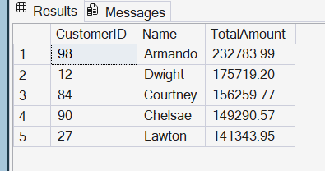
Q2. Find the number of products supplied by each supplier.
Display SupplierID, SupplierName, and ProductCount. Only include suppliers that have more than 10 products.
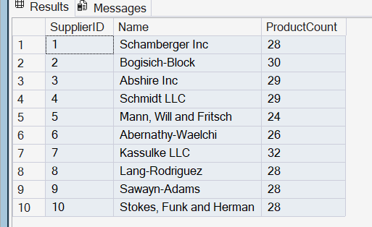
Q3. Identify products that have been ordered but never returned.
Show ProductID, ProductName, and total order quantity.

Q4. For each category, find the most expensive product.
Display CategoryID, CategoryName, ProductName, and Price. Use a subquery to get the max price per category.

Q5. List all sales orders with customer name, product name, category, and supplier.
For each sales order, display:
OrderID, CustomerName, ProductName, CategoryName, SupplierName, and Quantity.
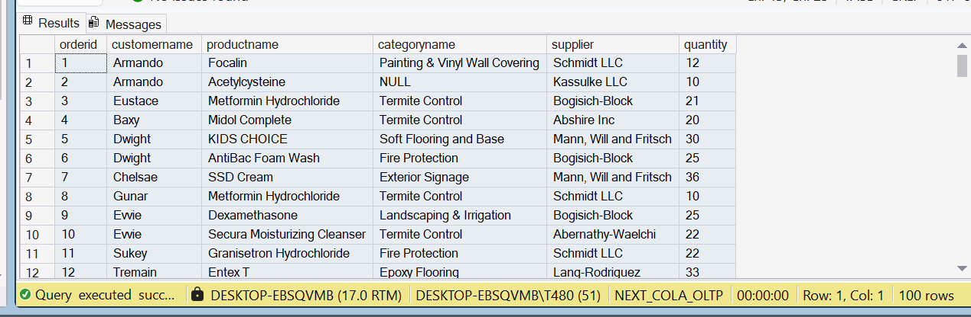
Q6. Find all shipments with details of warehouse, manager, and products shipped.
Display:
ShipmentID, WarehouseName, ManagerName, ProductName, QuantityShipped, and TrackingNumber.
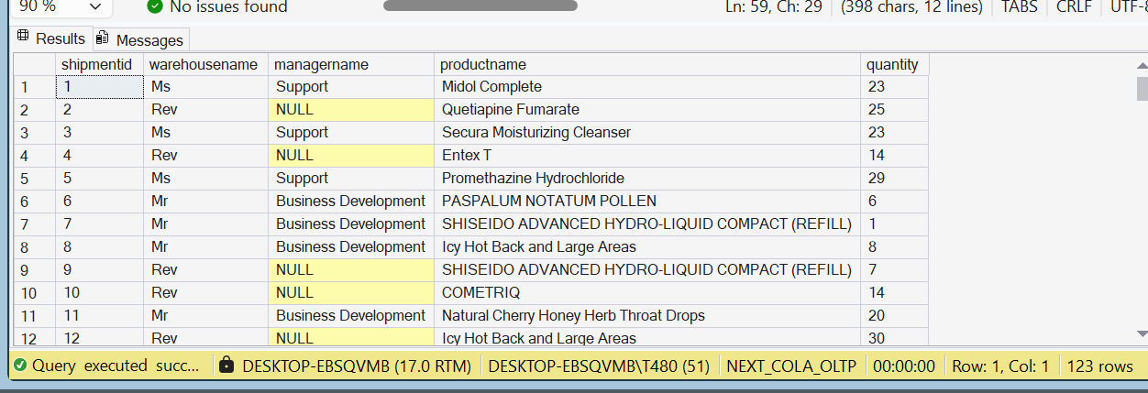

Q7. Find the top 3 highest-value orders per customer using RANK(). Display CustomerID, CustomerName, OrderID, and TotalAmount.

Q8. For each product, show its sales history with the previous and next sales quantities (based on order date). Display ProductID, ProductName, OrderID, OrderDate, Quantity, PrevQuantity, and NextQuantity.

Q9. Create a view named vw_CustomerOrderSummary that shows for each customer:
CustomerID, CustomerName, TotalOrders, TotalAmountSpent, and LastOrderDate.

Q10. Write a stored procedure sp_GetSupplierSales that takes a SupplierID as input and returns the total sales amount for all products supplied by that supplier.

